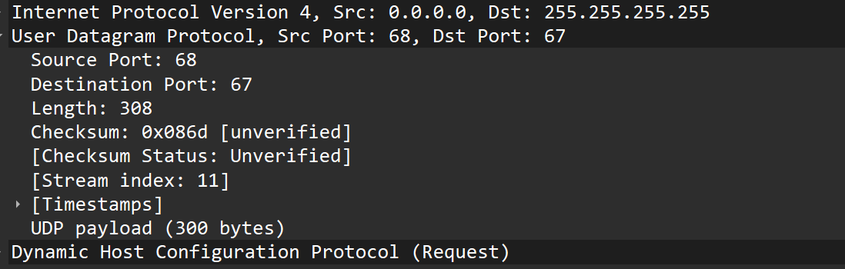

→ In above, we have made a dhcp request for our pc by turning off then turning on wifi such that dhcp work on UDP packet.. Why dhcp or dns work on UDP instead of TCP?? because its just a simple request for ip-address which make UDP very wise choice to use.
From above traced udp packet, all 4 field I.e source port, destination port, length, and checksum are of 16 bits, although the size may seems small but the each field can store value of 16 bits.

1) source port hold the port number of sending application
2) destination port hold the port number of receiving application
3) Length field indicate the entire packet of UDP which is 308 bytes where 8 bytes is UDP header and 300 bytes of UDP payload as seen from above
4)Checksum is the value which is use for error checking of header and data. It is optional in IPv4 and that’s why it is showing unverified.

Note;- UDP itself does not guarantee the delivery of data on transport layer of tcp ip model which means application layer should be responsible for re-transmissions if needed. Real-time data transfer like phone call and video call doesnot require retransmission and thats why udp is better for real time application and better than tcp.
To search UDP packet in wireshark, we search for DHCP rather than UDP for filtering, because DHCP works basically over UDP… we turnoff wifi and then turnon, we see dhcp

